Workshop Assignment Documentation

**Requirements**

Creation of an application using ListBoxes and Buttons to calculate and display the registration cost, the lodging cost and total cost.

**Building of the Interface**

**Tools used**

1. 11 label controls
2. 2 buttons controls
3. 2 list box controls

**Label control**

Label control is one of the important tools of visual studio located in the toolbox. It displays static text, titles and screen output from operations. In this context, I used it to display the title of the project, the names of the charges, the heading of the programs offered and the heading of various locations where the courses are given. (See below GUI)

**ListBox control**

ListBox control is located under the toolbox and its role is to display a list of items from which the user can select one or more. Since, it is mentioned in the requirements of the project that the user select a workshop from one listbox and a location from another ListBox, I decided to use the Forms designer, which is one of the two approaches to build a ListBox control in Windows Forms to create the user interface at design-time. Using the items Collection from the Properties Window, I populated the list box control with the items mentioned in the requirements. (See below GUI)

**Button control**

Like label and listbox controls, button control is also located in the toolbox. It allows user to interact with the program. In this case, I used them to create Select and Exit buttons. With the Select button, user can easily select any item in the list box and exit or close the program using the Exit button. (See below GUI)

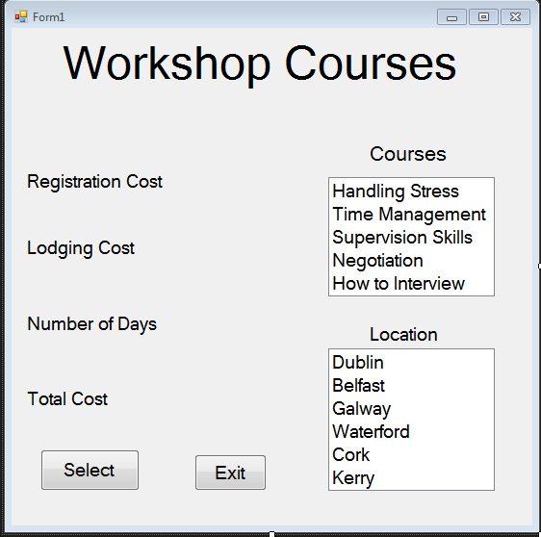

**Fig 1**- **GUI of the application with all the elements specified in the project requirements.**

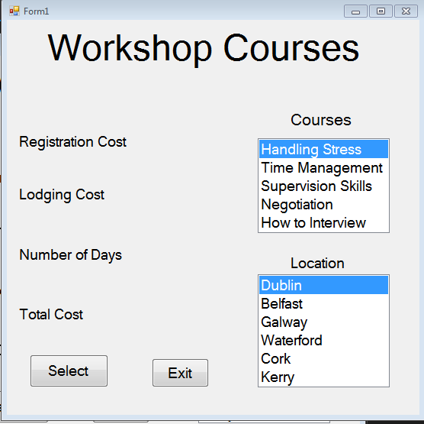

**Fig 2- Selection of items in the list box**

On this interface, I have selected course program and the location where it is given.

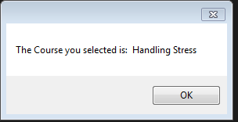

**Fig 3- Here we have the result the selection of the course**

After activating the Select button, a first window bearing the selection made shows up.

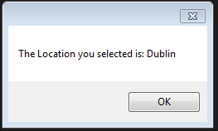

**Fig 4- Here we have the result of the selection of the location**

Immediately after the display of Fig 3, the application shows the result of the selected location.

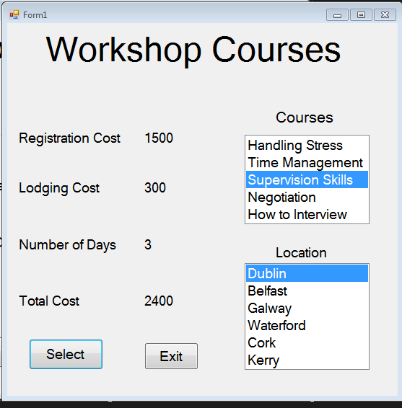

**Fig 5- Application performance**

Subsequently in the above Fig 5, the application displays its full performance by putting out the end-result of the execution of the input data.

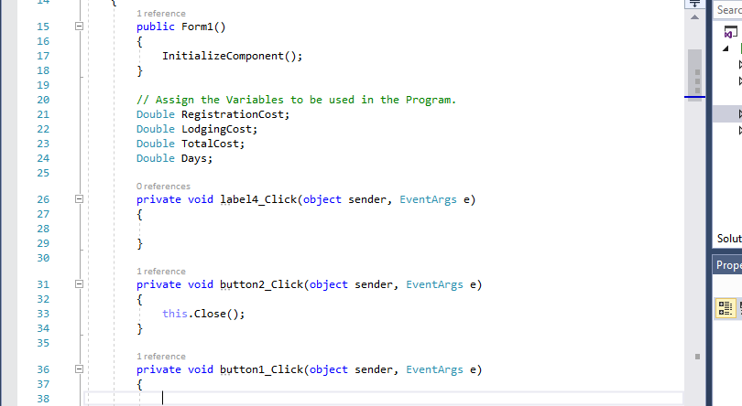

**Fig 6- Initialisation of variables**

**Application coding**

The application coding consists of 4 parts:

1- Variables declaration

2- Selection of variables

3- Application of Switch statement

4- Outputting of final result

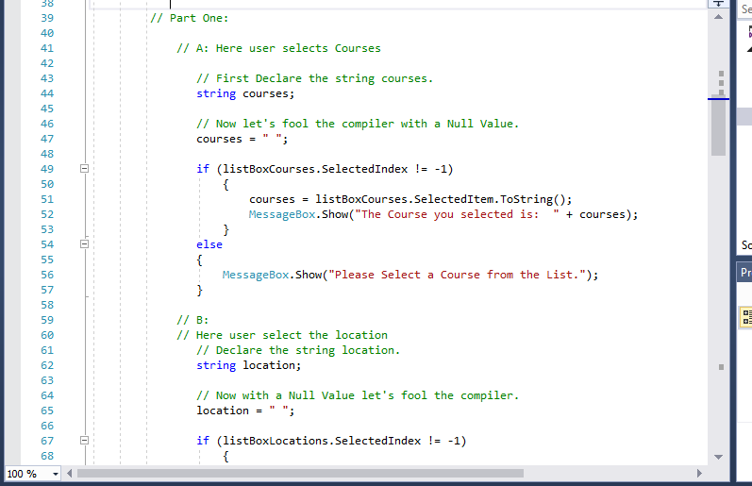

**Fig 7- Introduction of IF-ELSE loop.**

In Fig 7 I introduced the conditional statement if - else for checking the data or conditions that I provided in the head of if statement by using the logical operator**! =**. Since the IF condition is false, I proceeded to the ELSE statement to execute the code in it.

I also made use of the ListBox.SelectedIndex Property with a zero-based index an item selected. The value would have been -1 if no item was selected. The project consists of many items; therefore, I introduced the ListBox.SelectedItems Property in the code in order to obtain all the items.

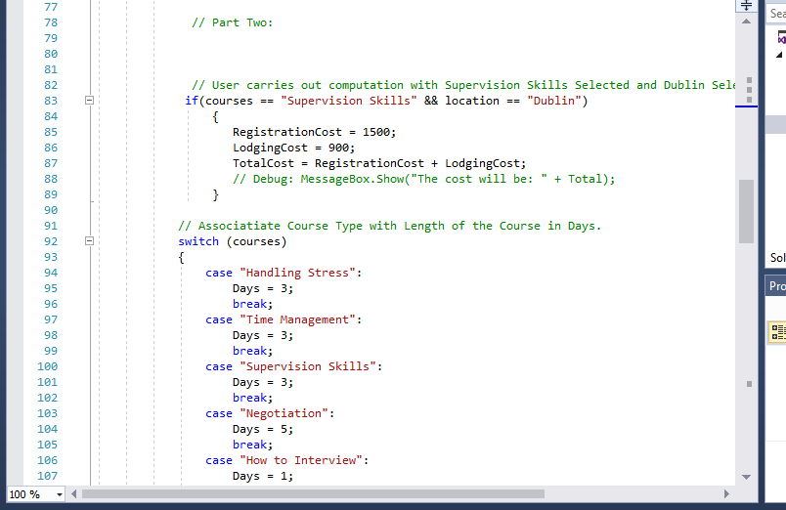

Fig 8- Application of Switch statement and computation of costs

Considering that the project presents large number of compares (course duration, locations and fees), it is suitable to use the Switch statement to build the application. The switch statement works under variable (integer/character literal) data type only and this project requirement contains the types of variable enumerated above. One of the particularities of switch statement is that during execution, it decides which path to take, instead of checking which case is satisfied and only goes to default when everything else fails. The switch statement also offers a clean and easy to read coding operation as compared to IF, IF-ELSE and ELSE statements.

Using the example given in the project requirement, I set a mathematical operation with Supervision Skills as Course and Dublin as Location. I proceeded developing the Switch statement by using **Courses and Locations** as the Switch TetExpression and **each course** and **location** as Case by associating them with their duration and fees.

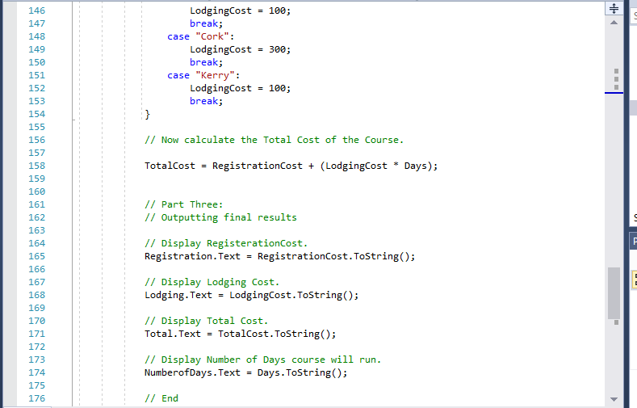

**Fig 9- Final output coding of the application**

The total cost is now calculated and set for display.

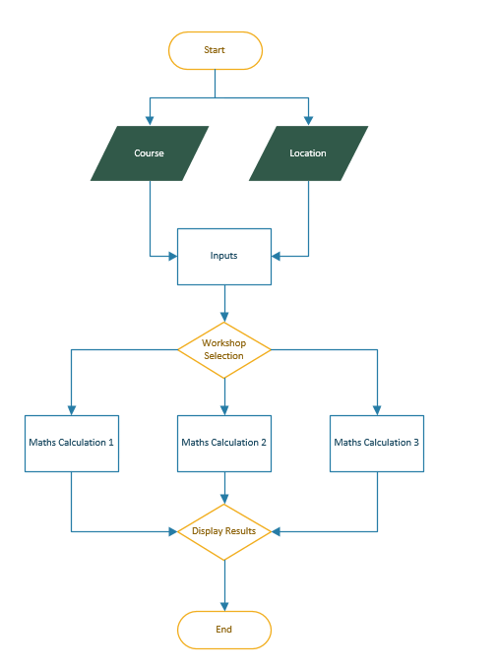

**Fig 9- Flowchart diagram of the application**

This illustrates the design process of the application